Subj: Engineering Maths Course: BESE 15 & TE 46A
Instr: Maj Muhammad Naeem
- Question Paper Mid Term Exam Apr 2010 of BESE 15 A & B

MILITARY COLLEGE OF SIGNALS
MID TERM EXAM
(BESE 15-Apr 2010)
Engineering Math’s
Instr: Maj Muhammad Naeem Max Marks: 30
Semester: Second Time: 90 min
--------------------------------------------------------------------------------------------------------------------

Notes: Note the following instructions.
1. Read all the questions carefully and solve them accordingly
2. Show the details of your working
3. Each question carries six marks
4. Programmable Calculators are N0T allowed
5. Attach the question paper at the end of your answer sheet
-----------------------------------------------------------------------------------------------------------
1. Mid Term Question Paper

Q.1 An archaeologist excavates a bone and measures its content of radioactive carbon ₆C¹⁴. If the result is 25% of the content present in bones of a living organism, +what can be said about the age of the bone? The half life of ₆C¹⁴ is 5730 years.

Q.2 Using differential equation, find the minimum initial velocity of projection for a body from the surface of the earth. Radius of earth is 6372 km.

Q.3 A tank contains 1000 gal of water in which 200 Ib of salt are dissolved. Fifty gallons of brine, each containing (1 +cost) Ib of dissolved salt, run into the tank per minute. The mixture, kept uniform by stirring runs out at the same rate. Find the amount of salt in the tank at any time t?

Q.4 a. Solve x²y// - 0.2xy/ + 0.36y =0
b. Find a second-order homogeneous linear differential equation for which the functions, cos2πx, sin2πx are the solutions

Q.5 a. Solve y//+y/+9.25y = 9.25(4+e^{-x}), where y (0) =7; y/ (0) = - 2
b. Are the functions x |x| ,x² are linearly dependent or independent over the interval 0≤x≤1?

- Quizzes
a. Quize#1
(1) Solve the differential equation xy/=y+3x⁴ cos²(y/x), y(1)=0
(2) Solve the differential equation xy/=y+x² sec(y/x), y(1)=π
(3) Solve the differential equation xyy/=2y²+4x², y(2)=4
b. Quize#2
(1) Apply the given operator to the given functions
D²+3D; Cosh3x, e^{-x}+e^{2x},10-e^{-3x}
(2) D-4; 3x²+4x, 4x^{4x}, cos2x-sin2x
(3) (D-2)(D+1); e^{2x},xe^{2x},e^{-x},xe^{-x}
c. Quize#3
(1) Find the Laplace Transform of cos²wt
(2) Find the Laplace Transform of sin2tcos2t
(3) Find the Laplace Transform of e^{t}cosh3t
3. Assignments
a. Asg#1
(1) Solve y/+ky=e^{-kx}
(2) Solve y/+4y=cosx
(3) xy/=2y+x³e^{x}
b. Asg#2
(1) Solve the linear differential equation xy/-ay=x+1
(2) Solve the linear differential equation (x-1)³y/+4(x-1)²y=x+1
(3) Solve the linear differential equation xy-y/=y³e^{-x2}
c. Asg#3
(1) Find the laplace inverse transform of 1/(s+1)²
(2) Find the laplace inverse transform of 12/(s-3)⁴
(3) Find the laplace inverse transform of 4/(s²-2s-3)

- Solution of quizzes
  - Quize#1
(1)
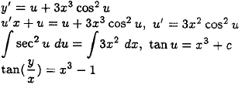
(2)
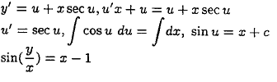

(3)
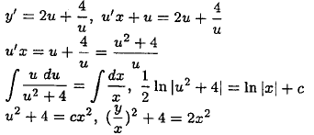

  - Quize#2
(1)
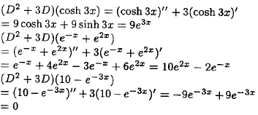
(2)
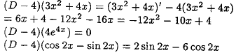

(3)
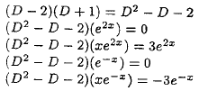

  - Quize#3

(1)
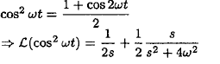

(2)
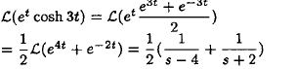

(3)
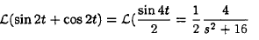

- Solution of Assignments
a. Asg#1
(1)
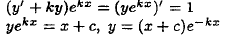

(2)

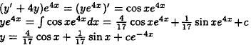

(3)

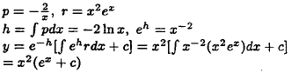
b. Asg#2
(1) y/-(a/x)y=(x+1)/x
Here P=-a/x and IF=1/xª
y=xª[∫(x^{-a}+x^{-(a+1)}dx+c]
y=[x/(1-a)-1/a]+cxª

- y/+[4/(x-1)]y=x+1/(x-1)³
Here P=4/(x-1) and IF =(x-1)⁴
Y=1/(x-1)⁴ [x³/3-x+c]
- Dividing the equation by y⁶, we get
-5y⁻⁶y/-5(y⁻⁵)/x= -5x²
Putting v=y⁻⁵ and differentiating, we get v/-5v/x=-5x²
IF=1/x⁵
v=x5(5/2x²+c)

c. Asg#3
(4)

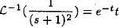
(5)

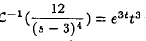
(6)

